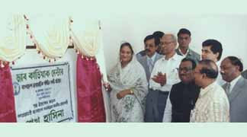
Hasina opens DAB cardiac centre
Prime Minister Sheikh Hasina inaugurating the DAB Cardiac Centre at Shahbagh in the city on Thursday.
Prime Minister Sheikh Hasina on Thursday opened a newly installed "DAB Cardiac Centre at BIRDEM hospital in city hoping that the heart patients would not need to go abroad for treatment, reports BSS.
The DAB Cardiac Centre is the fulfillment of the government's commitment to ensure improved health care of the people she said and expressed the hope that the centre would contribute greatly to the treatment of heart diseases.
Presided over by the President of Bangladesh Diabetic Association (DAB) Prof. Wahiduddin Ahmed, the opening function was addressed by Health and Family Welfare Minister Sheikh Fazlul Karim Selim, State Minister for Social Welfare, Dr. Mozammel Hossain, State Minister for Health and Family Welfare, Dr. M Amanullah, Swedish Ambassador to Bangladesh Anders Johnson, Health and Family Welfare Secretary Mohammad Rafiqul Alam and DAB Secretary General Prof. AK Azad Khan.
The DAB Cardiac 80-bed Centre, equipped with all ultra-modern emergency-outdoor-indoor heart treatment facilities, has emerged as an ideal centre. Sweden based Swedish-Bengal Medicine Centre (SBMC) under an agreement will provide technical assistance and support to the centre.
Besides rendering service to the heart patients, Sweden would build an efficient manpower along with creating a culture of dedicated service to the ailing humanity.
Appreciating the endeavors of the DAB for setting up such an ultra modern cardiac centre, the Prime Minister expressed the hope that the patients of this region would come to this centre for better treatment.
She thanked the experts from Sweden for extending their cooperation for building developed and skilled technology in the field of cardiac treatment.

